

Student Name | Highlighted questions are relevant for 2017 U3 AOS 1
Teacher | GSL | HAL | LLE | MDI

Chemistry Unit 4

SAC 1: Task 3, Supplying and using energy Test

(Concepts from Chapters 23 - 28)

Term 3 Week 6, 2015
Reading time: 5 minutes
Writing time: 65 minutes

Section | Number of questions | Number of questions to be answered | Number of marks
A | 11 | 11 | 12
B | 5 | 5 | 36
Total 48

- Students are permitted to bring into the examination room: pens, pencils, highlighters, erasers, sharpeners, rulers, and one scientific calculator.
- Students are not permitted to bring into the examination room: blank sheets of paper and/or white out liquid/tape.
Materials supplied
- This question and answer book of 11 pages including a multiple choice answer sheet on page 6.
- A data booklet
Instructions
- Write your name in the space provided above on this page and circle your teacher code.
- All responses must be written in English.
- Do not write on the Data Book.

Students are NOT permitted to bring mobile phones and/or any other unauthorised electronic devices into the examination room.

Students must not disclose the contents of the task; to do so will be a breach of VCE guidelines and will be dealt with according to VCAA regulations.

SECTION A: Multiple-choice questions

Instructions for Section A
Answer all questions in pencil on the answer sheet provided for multiple choice questions.
Choose the response that is correct or that best answers the question.
A correct answer scores 1, an incorrect answer scores 0. Marks will not be deducted for incorrect answers.
No marks will be given if more than one answer is completed for any question.

Use the following information for Questions 1 and 2
Wind turbines capture wind energy within the area swept by their blades. They produce a power output proportional to the air density and the wind speed cubed. The spinning blades drive an electrical generator that produces electricity for export to the grid.

Question 1
The energy transformations that occur when a wind turbine is generating energy are:
A. | mechanical energy electrical energy
B. | kinetic energy thermal energy mechanical energy electrical energy
C. | kinetic energy mechanical energy electrical energy
D. | mechanical energy kinetic energy mechanical energy electrical energy

Question 2
Energy that is generated from wind turbines is considered to be:
A. | Sustainable because it is produced by a resource that will not run out
B. | Renewable because it produces no/little CO₂ emissions
C. | Non-renewable because the wind turbines are noisy and visually awful
D. | Renewable because it is a reliable source of energy

Question 3
A cell that is popular in military uses is the cell formed from the reaction of lithium and sulfur dioxide. The cell is expensive but is capable of producing a voltage of almost 3 volts. The overall equation for this cell is:
2Li + 2SO₂ Li₂S₂O₄

In this reaction, the oxidation number of sulfur:
A. | remains unchanged
B. | changes from +2 to +4
C. | changes from +4 to +6
D. | changes from +4 to +3
Question 4
For the galvanic cell consisting of Fe²⁺/Fe and Pb²⁺/Pb, the standard cell potential is
A. | 0.57 V with a positive Fe electrode
B. | 0.57 V with a positive Pb electrode
C. | 0.31 V with a positive Fe electrode
D. | 0.31 V with a positive Pb electrode

Question 5
When considering the following reactions:
1) S (s) + O₂ (g) SO₂ (g) ΔH = -297 kJ mol⁻¹
2) SO₂ (g) + ½ O₂ (g) SO₃ (g) ΔH = -98 kJ mol⁻¹
3) S (s) + 1 ½ O₂ (g) SO₃ (g)
The ΔH for Equation 3 would be
A. | - 395 kJ mol⁻¹
B. | + 395 kJ mol⁻¹
C. | - 199 kJ mol⁻¹
D. | + 199 kJ mol⁻¹
Question 6
Faraday’s first law of electrolysis states that
A. | The amount of chemical energy lost or gained will depend on the quantity of reactants converted to products
B. | The amount of energy released in a reaction is directly proportional to the amount of substance that is reacting
C. | In order to produce 1 mole of a metal, a whole number of moles of electrons must be consumed.
D. | The amount of substance produced at the cathode is directly proportional to the quantity of electricity (charge) passed through the cell

Question 7
The following diagram is a representation of the operation of a Galvanic Cell:
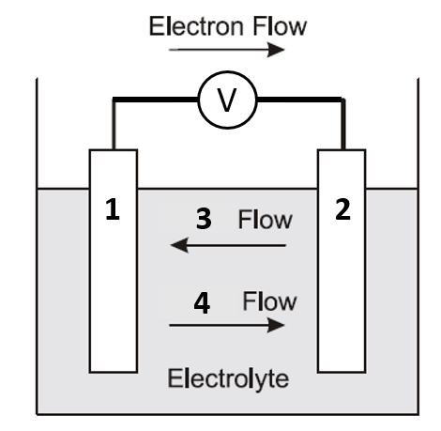
The labels in order 1, 2, 3, 4 are:
A. | Cathode (-), anode (+), anion, cation
B. | Cathode (-), Anode (+), cation, anion
C. | Anode (-), Cathode (+), anion, cation
D. | Anode (-), Cathode (+), cation, anion

Use the following information for Questions 8 and 9
The lead-acid accumulator (car battery) is a well-known example of a secondary cell. The battery consists of six separate cells connected in series. The overall equation for the reaction during discharge is:
Pb (s) + PbO₂ (s) + 2 H₂SO₄ (aq) 2 PbSO₄ (s) + 2 H₂O (l)
Question 8
Which of the following half equations represents the reaction that occurs at the anode during recharging of the car battery
A. | Pb (s) + SO₄²⁻ (aq) PbSO₄ (s) +2e⁻
B. | PbSO₄ (s) +2e⁻ Pb (s) + SO₄²⁻ (aq)
C. | PbO₂ (s) + 4 H⁺ (aq) + SO₄²⁻ (aq) + 2e⁻ 2 H₂O (l) + PbSO₄ (s)
D. | 2 H₂O (l) + PbSO₄ (s) PbO₂ (s) + 4 H⁺ (aq) + SO₄²⁻ (aq) + 2e⁻

Question 9
Which of the following features of the lead-acid battery enables it to function as a secondary cell?
A. | During recharging, additional reactions may occur.
B. | The products of the discharge reactions adhere to the electrodes
C. | The electrolyte used is approximately 4M H₂SO₄ solution
D. | Contact between the electrodes is prevented by the presence of a porous separator

Question 10
A metal cup containing a 90.0g of water was placed over a burning paraffin candle. After some time, the change in temperature of the water was recorded, as well as the mass of the paraffin that was burned and the heat of combustion of the paraffin in the candle was calculated as -10.9 kJ/g. Which of the following statements about this experiment is true?
A. | If ΔT of the water was found to be 19.5˚C, then the energy gained by the water would be calculated as 8151 J.
B. | This experimental value for the heat of combustion of paraffin would be lower than the actual due to heat loss to the surrounding air.
C. | The energy that is absorbed by the metal cup would have no effect on the experimental value that was calculated.
D. | In order to calculate the heat of combustion, the value for the energy gained by the water should be multiplied by the mass of the paraffin that was burned.

Question 11
2.6 g ethene underwent complete combustion. The energy released was used to heat 2.34 kg of water. Assuming that no heat was lost, the temperature of the water would have increased by:
A. | 13.4 ˚C
B. | 0.0134 ˚C
C. | 1.34 x 10⁴ ˚C
D. | 39.4 ˚C

Question 12
Which of the following would be predicted to spontaneously reduce aqueous Pb²⁺ ions, but not spontaneously reduce aqueous Co²⁺ ions?
A. | Ni²⁺ (aq)
B. | Sn (s)
C. | H⁺ (aq)
D. | Fe (s)

END OF SECTION A

Multiple Choice Answer Sheet
This answer sheet must not be detached from this booklet.

INSTRUCTIONS FOR MULTIPLE CHOICE ANSWER SHEET
Use a PENCIL for ALL entries. For each question, shade the box which indicates your answer.
Marks will NOT be deducted for incorrect answers.
NO MARK will be given if more than one answer is completed for any question.
If you make a mistake, ERASE the incorrect answer - DO NOT cross it out.
1 |  | A |  | B |  | C |  | D
2 |  | A |  | B |  | C |  | D
3 |  | A |  | B |  | C |  | D
4 |  | A |  | B |  | C |  | D
5 |  | A |  | B |  | C |  | D
6 |  | A |  | B |  | C |  | D
7 |  | A |  | B |  | C |  | D
8 |  | A |  | B |  | C |  | D
9 |  | A |  | B |  | C |  | D
10 |  | A |  | B |  | C |  | D
11 |  | A |  | B |  | C |  | D
12 |  | A |  | B |  | C |  | D
13 |  | A |  | B |  | C |  | D
14 |  | A |  | B |  | C |  | D
15 |  | A |  | B |  | C |  | D

SECTION B

Instructions for Section B: Answer all questions in the spaces provided. Write using black or blue pen. To obtain full marks for your responses you should:
- give simplified answers with an appropriate number of significant figures to all numerical questions; unsimplified answers will not be given full marks.
- show all working in your answers to numerical questions. No marks will be given for an incorrect answer unless it is accompanied by details of the working.
- Make sure chemical equations are balanced and that the formulas for individual substances include an indication of state; for example, H_{2(g);} NaCl_{(s)}

Question 1 (6 marks)
A 2.15 g sample of peanuts is burned. The heat released raises the temperature of a 100.0 g sample of water from 18.2 to 31.5 ˚C. The mass of the sample of peanuts after the experiment is 1.78 g. The water was only able to absorb 25.0% of the heat released by the burning peanuts.
- Draw a labelled diagram to show how this experiment may have been set up.
2 marks
- Assuming that 1.00 calorie (Cal) is equal to 4.18 kJ:
- Calculate the energy, in calories, that was absorbed by the water.

- Calculate the calorie content of the peanuts in Cal/g.
2 + 2 = 4 marks
Question 2 (8 marks)
A student constructed two electrochemical cells as shown below.
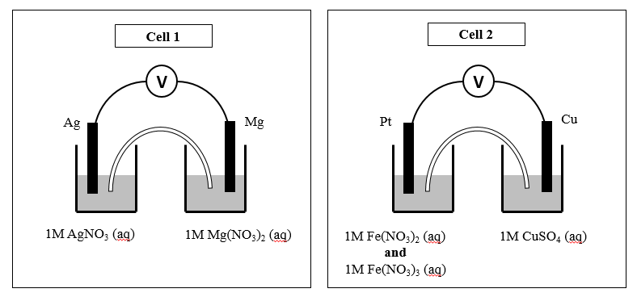
- Describe the changes that occur in each half-cell of Cell 1 as the cell operates. Include balanced half-equations to support your descriptions.
4 marks

- In cell 2, the solution in one half cell is initially orange due to the mixture of pale green Fe²⁺ and orange Fe³⁺ ions. The other half cell is blue due to the Cu²⁺ ions. Describe the colour changes the student would see in each half-cell of Cell 2 if the reaction proceeded until no further changes took place.
2 marks
- What is the purpose of the salt bridge joining each half cell?
2 marks

Question 3 (7 marks)
Proton exchange membrane (PEM) (or “solid polymer”) fuel cells react hydrogen with oxygen and use an electrolyte that is composed of a solid polymer film that consists of a form of acidified Teflon. PEM fuel cells typically operate at 70 to 90 ºC.
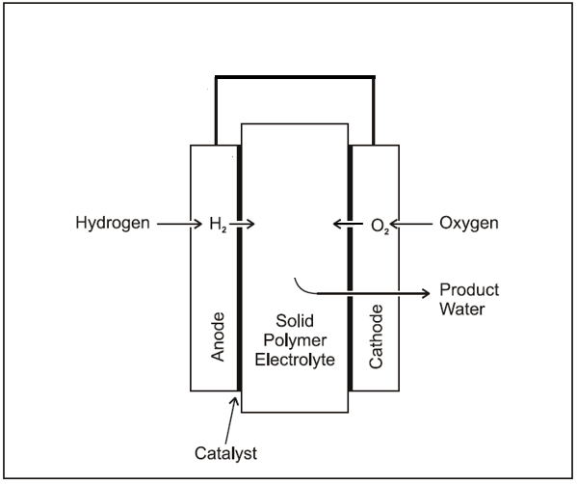
- Explain why the following statement is considered as an advantage of PEM fuel cells:
- The PEM fuel cell operates at low temperatures and pressures
1 mark
- On the diagram above, use an arrow to indicate the direction of electron flow in the cell when it is producing energy.
1 mark

- PEM fuel cells can also run using methanol fuel directly. These type of cells are supplied with liquid methanol and water at the anode, and air or oxygen gas at the cathode. An acidic electrolyte is present in the cell.

- Methanol is converted to carbon dioxide and H⁺ ions at the anode. Write an equation for this reaction.

- At the cathode oxygen, from the air, ionizes and reacts with hydrogen ions to form water. Combine the anode and cathode reactions to write an overall cell reaction for the direct methanol PEM fuel cell.
2 + 2 = 4 marks
- Describe one disadvantage of the direct PEM compared with the standard PEM fuel cell.
1 mark
Question 4 (6 marks)
A solution of an iron salt is electrolyzed in a cell by passing 0.22 A through the cell for 1.5 hours. The mass of iron metal deposited on one electrode was 0.343 g.

- State the name and polarity (positive or negative) of the electrode at which the iron metal was deposited.
1 mark
- i. Calculate the amount (in mol) of iron deposited.

ii. Calculate the amount (in mol) of electrons used to deposit the iron.

ii. Hence calculate the charge on the iron ion in the salt.
1 + 1 + 1 = 3 marks

- Explain why it is not possible to deposit potassium by the electrolysis of a potassium salt solution.
2 marks

Question 5 (3 marks)
The combustion of 1.50 g of aluminium powder, Al (s) in oxygen releases 46.5 kJ of energy
Write a balanced thermochemical equation to represent this reaction. Include units in your answer.
Question 6 (6 marks)
In order to determine the experimental value for the heat of fusion of ice, the amount of energy absorbed by ice when it melts (J g⁻¹), a group of chemistry students placed a 25.8 g sample of ice into a paper coffee cup with 100.0 g of water at 35.4 ˚C. They placed a lid on the cup and inserted a thermometer (Experiment 1). After several minutes the ice completely melted and the water temperature had lowered to 18.1 ˚C.

The students then repeated the experiment (Experiment 2) with the following changes:
- They used a calorimeter instead of a coffee cup (masses of ice and water were the same)
- Before conducting the experiment they passed a current of 1150 mA at 5.84 V through the electric heater in the calorimeter and noted a temperature rise of 1.16 ˚C in 63 seconds

- What was the student’s experimental value for the heat of fusion (J g⁻¹) of ice in Experiment 1?
2 marks

- What was the calibration factor for the calorimeter used in Experiment 2?
2 marks

- Provide an explanation to support whether you believe the value calculated for the heat of fusion of ice in Experiment 2 would have been bigger, smaller, or the same as the value calculated in Experiment 1.
2 marks

END OF QUESTION AND ANSWER BOOKLET

